# Testing as a Driver for Software Development

## What is Testing as a Driver for Software Development

**# Source**: **Chatgpt (GPT-5-Standard) at [8/13/2025]**

**Testing as a Driver for Software Development** means using testing not just as a *check at the end*, but as a **guiding force** throughout the software development process.  
 Instead of “build first, test later,” the testing process **shapes design, coding, and delivery decisions** from the start.

## **What It Means**

**# Source**: **Chatgpt (GPT-5-Standard) at [8/13/2025]**

* **Testing influences requirements** – Tests clarify what “done” means.
* **Testing shapes code structure** – Writing tests first (e.g., TDD) impacts how developers design code.
* **Testing accelerates feedback** – Continuous testing helps detect issues immediately.
* **Testing ensures maintainability** – A solid test suite enables safe refactoring.

## **Key Approaches That Make Testing a Driver**

**# Source**: **Chatgpt (GPT-5-Standard) at [8/13/2025]**

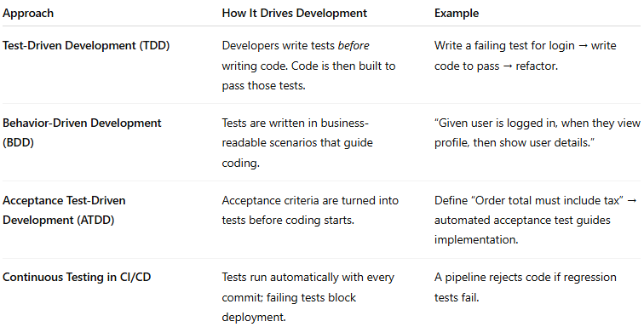

| **Approach** | **How It Drives Development** | **Example** |
| --- | --- | --- |
| **Test-Driven Development (TDD)** | Developers write tests *before* writing code. Code is then built to pass those tests. | Write a failing test for login → write code to pass → refactor. |
| **Behavior-Driven Development (BDD)** | Tests are written in business-readable scenarios that guide coding. | “Given user is logged in, when they view profile, then show user details.” |
| **Acceptance Test-Driven Development (ATDD)** | Acceptance criteria are turned into tests before coding starts. | Define “Order total must include tax” → automated acceptance test guides implementation. |
| **Continuous Testing in CI/CD** | Tests run automatically with every commit; failing tests block deployment. | A pipeline rejects code if regression tests fail. |

## **Benefits of Testing-Driven Development**

**# Source**: **Chatgpt (GPT-5-Standard) at [8/13/2025]**

* **Early Defect Prevention** – Bugs found in design phase are cheaper to fix.
* **Clear Definition of Done** – Tests specify expected behavior explicitly.
* **Better Code Quality** – Code is modular and testable.
* **Faster Feedback** – Developers get immediate alerts if changes break something.
* **Supports Agile & DevOps** – Fits into short, iterative cycles with automation.

## **How It Fits in the SDLC**

**# Source**: **Chatgpt (GPT-5-Standard) at [8/13/2025]**

* **Requirements Phase** → Define testable acceptance criteria.
* **Design Phase** → Plan test scenarios alongside system design.
* **Implementation** → Write tests first (TDD/BDD), then implement code.
* **Testing Phase** → Automated regression suite verifies all requirements.
* **Maintenance** → Existing tests guard against new defects.

## Types

### 1-Test-Driven Development (TDD)

#### What is Test-Driven Development (TDD)

**# Source**: **Chatgpt (GPT-5-Standard) at [8/13/2025]**

**Test-Driven Development (TDD)** is a **software development approach** where you write automated tests *before* writing the actual code.  
 It follows a short, repeatable cycle called **Red → Green → Refactor**:

#### The TDD Cycle

**# Source**: **Chatgpt (GPT-5-Standard) at [8/13/2025]**

1. **Red** – Write a small, failing test (because the feature/code doesn’t exist yet).
2. **Green** – Write just enough code to make the test pass.
3. **Refactor** – Improve the code’s structure and readability while keeping tests passing.

Then repeat the cycle for the next small feature.

#### How It Works (Example)

**# Source**: **Chatgpt (GPT-5-Standard) at [8/13/2025]**

Let’s say we need a function to add two numbers:

* **Step 1:** Write a test: *“add(2, 3) should return 5”* → it fails (Red).
* **Step 2:** Write minimal code: return a + b; → test passes (Green).
* **Step 3:** Refactor if needed (e.g., handle edge cases) → tests still pass.

##### Scenario: We want a function add(a, b) that returns the sum of two numbers.

##### Step 1: Write a Test (RED phase)

**# Source**: **Chatgpt (GPT-5-Standard) at [8/13/2025]**

* **Goal:** Define the expected behavior before writing the actual function logic.
* **Action:** Write a test that says: “If we add 2 and 3, the result should be 5.”
* **Why first?** Forces you to think about the requirements and API *before* coding the solution.
* **Result:** Since the function doesn’t exist yet (or is unimplemented), the test fails.
* **Status:** **RED** — this indicates the code doesn’t yet meet the requirement.

**Example (Python + pytest):**

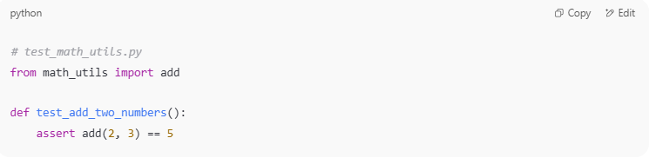

# test_math_utils.py

from math_utils import add

def test_add_two_numbers():

assert add(2, 3) == 5

If add is not defined, pytest will throw an error:

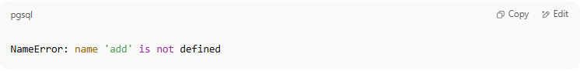

NameError: name 'add' is not defined

##### Step 2: Write Minimal Code (GREEN phase)

**# Source**: **Chatgpt (GPT-5-Standard) at [8/13/2025]**

* **Goal:** Write the simplest code to make the test pass — no extra features, no optimizations.
* **Action:** Implement add(a, b) so that it returns the sum.
* **Why minimal?** Prevents overengineering and keeps you focused on passing the current test.
* **Result:** The test passes.
* **Status:** **GREEN** — requirement met.

**Example:**

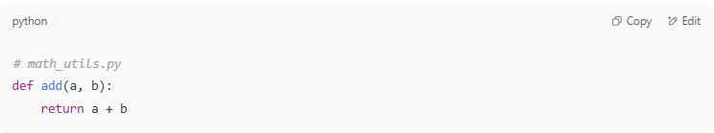

# math_utils.py

def add(a, b):

return a + b

Run the test again:

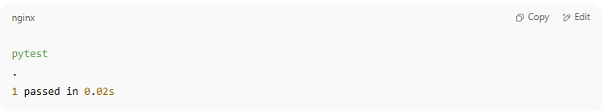

pytest

.

1 passed in 0.02s

##### Step 3: Refactor (REFACTOR phase)

**# Source**: **Chatgpt (GPT-5-Standard) at [8/13/2025]**

* **Goal:** Clean up code or improve design without changing its behavior.
* **Action:**
  + Improve naming
  + Remove duplication
  + Add handling for edge cases (optional, if needed now)
* **Why now?** The tests ensure you’re not breaking functionality while improving code.
* **Result:** Code is cleaner, tests still pass.
* **Status:** Still **GREEN**.

Example refactor — maybe you decide to handle None inputs:

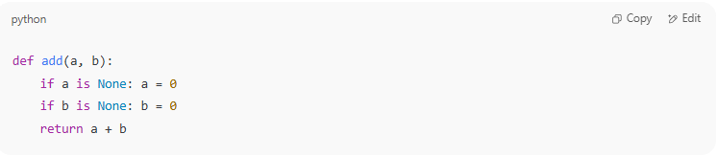

def add(a, b):

if a is None: a = 0

if b is None: b = 0

return a + b

Run tests again — still pass:

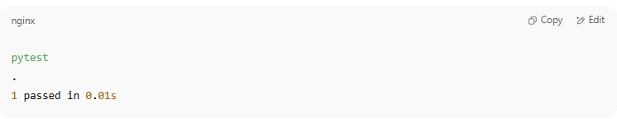

pytest

.

1 passed in 0.01s

##### Red → Green → Refactor Loop Summary

**# Source**: **Chatgpt (GPT-5-Standard) at [8/13/2025]**

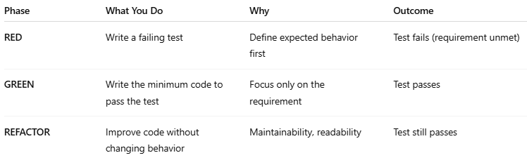

| **Phase** | **What You Do** | **Why** | **Outcome** |
| --- | --- | --- | --- |
| **RED** | Write a failing test | Define expected behavior first | Test fails (requirement unmet) |
| **GREEN** | Write the minimum code to pass the test | Focus only on the requirement | Test passes |
| **REFACTOR** | Improve code without changing behavior | Maintainability, readability | Test still passes |

💡 **Key Point:** TDD makes *automated tests* the driver of your development. Over time, you build a **safety net** of tests that catches regressions when you change code later.

If you want, I can give you the **same example in a flow diagram** so you can visualize the TDD cycle for this case.

#### Benefits

**# Source**: **Chatgpt (GPT-5-Standard) at [8/13/2025]**

* **Fewer bugs** – Problems are caught early.
* **Better design** – Writing tests first forces modular, testable code.
* **Confidence in changes** – Safe refactoring thanks to passing tests.
* **Living documentation** – Test cases explain how the code is expected to behave.

#### Common Misunderstandings

**# Source**: **Chatgpt (GPT-5-Standard) at [8/13/2025]**

* **Not only for testers** – It’s primarily a *developer* practice.
* **Not writing all tests upfront** – You write one small test at a time.
* **Not only for new projects** – You can apply TDD to maintenance and bug fixes.

#### TDD vs. Traditional Development

**# Source**: **Chatgpt (GPT-5-Standard) at [8/13/2025]**

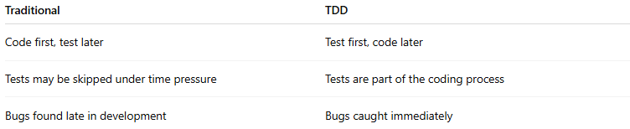

| **Traditional** | **TDD** |
| --- | --- |
| Code first, test later | Test first, code later |
| Tests may be skipped under time pressure | Tests are part of the coding process |
| Bugs found late in development | Bugs caught immediately |

### 2-Behavior-Driven Development (BDD)

#### What is Behavior-Driven Development (BDD)

**# Source**: **Chatgpt (GPT-5-Standard) at [8/13/2025]**

**Behavior-Driven Development (BDD)** is a **software development approach** that extends TDD by focusing on the **behavior** of the application from the **user’s perspective**.  
 It uses **plain, human-readable language** (often “Given–When–Then” format) so that **developers, testers, and business stakeholders** can collaborate on defining expected outcomes **before coding starts**.

#### Core Idea

**# Source**: **Chatgpt (GPT-5-Standard) at [8/13/2025]**

* **TDD** asks: *"What code should we write to pass this test?"*
* **BDD** asks: *"What behavior should the system show for this scenario?"*
* Tests are written in a **shared language** so everyone understands them.

#### The BDD Flow

**# Source**: **Chatgpt (GPT-5-Standard) at [8/13/2025]**

1. **Discuss** – Developers, testers, and stakeholders define requirements as behaviors.
2. **Describe** – Write scenarios in a structured format (Gherkin language).
3. **Implement** – Automate these scenarios as tests and write code to make them pass.

#### Example (Gherkin format)

**# Source**: **Chatgpt (GPT-5-Standard) at [8/13/2025]**

**Feature:** Login Function

Scenario: Successful login with valid credentials

Given the user is on the login page

When the user enters valid username and password

Then the user should be redirected to the dashboard

* **Given** – Setup or context.
* **When** – Action or event.
* **Then** – Expected outcome.

##### Scenario: Successful login with valid credentials

##### 1. Given – Setup / Context

**# Source**: **Chatgpt (GPT-5-Standard) at [8/13/2025]**

* **Purpose:** Describe the **initial state** or **preconditions** before the main action.
* **Meaning in this case:**
  + The user has already navigated to the login page of the application.
  + The application is up and running.
  + There’s an account with valid credentials in the system.

**BDD Representation:**

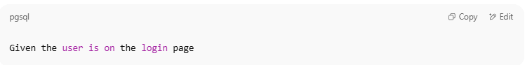

Given the user is on the login page

**Technical Setup Example (Selenium + Python):**

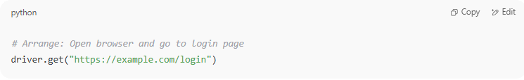

# Arrange: Open browser and go to login page

driver.get("https://example.com/login")

##### 2. When – Action / Event

**# Source**: **Chatgpt (GPT-5-Standard) at [8/13/2025]**

* **Purpose:** Describe the **specific action** the user takes.
* **Meaning in this case:**
  + The user types a valid username and password into the login form.
  + The user clicks the "Login" button.

**BDD Representation:**

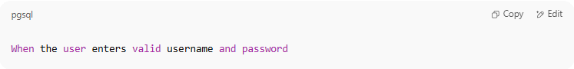

When the user enters valid username and password

**Technical Implementation Example:**

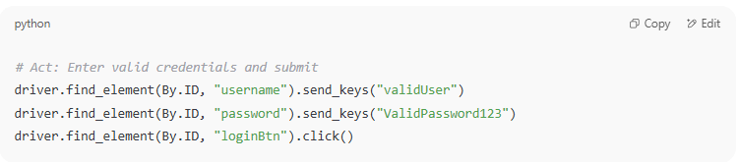

# Act: Enter valid credentials and submit

driver.find_element(By.ID, "username").send_keys("validUser")

driver.find_element(By.ID, "password").send_keys("ValidPassword123")

driver.find_element(By.ID, "loginBtn").click()

##### 3. Then – Expected Outcome

**# Source**: **Chatgpt (GPT-5-Standard) at [8/13/2025]**

* **Purpose:** Define the **result** that should happen after the action, if everything works correctly.
* **Meaning in this case:**
  + The application should authenticate the credentials.
  + The user should be redirected to the dashboard page.

**BDD Representation:**

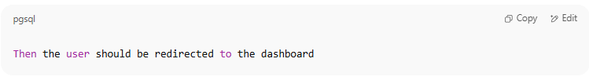

Then the user should be redirected to the dashboard

**Technical Verification Example:**

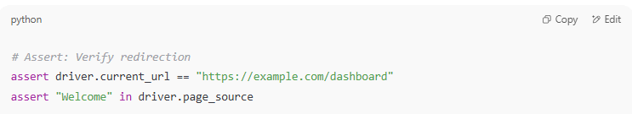

# Assert: Verify redirection

assert driver.current_url == "https://example.com/dashboard"

assert "Welcome" in driver.page_source

##### Full Example in Gherkin Syntax

**# Source**: **Chatgpt (GPT-5-Standard) at [8/13/2025]**

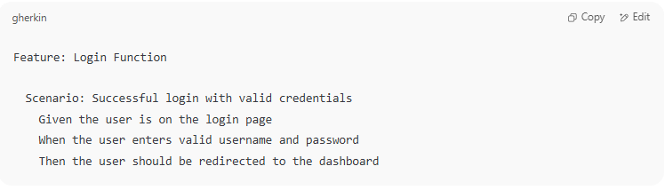

Feature: Login Function

Scenario: Successful login with valid credentials

Given the user is on the login page

When the user enters valid username and password

Then the user should be redirected to the dashboard

##### How It Fits into BDD

**# Source**: **Chatgpt (GPT-5-Standard) at [8/13/2025]**

* **Feature** = High-level description of what we’re testing (Login function).
* **Scenario** = One concrete example of behavior (valid login).
* **Given** = Sets up initial state (login page is open).
* **When** = Describes the trigger/action (entering credentials and submitting).
* **Then** = Describes the outcome (redirect to dashboard).

##### Visual Flow

**# Source**: **Chatgpt (GPT-5-Standard) at [8/13/2025]**

1. **Given** – *Where are we starting?* → Login page is loaded
2. **When** – *What action happens?* → Enter valid credentials + click login
3. **Then** – *What should happen?* → User lands on dashboard

#### Benefits

**# Source**: **Chatgpt (GPT-5-Standard) at [8/13/2025]**

* **Shared understanding** – Bridges communication gap between technical and non-technical teams.
* **Living documentation** – Scenarios double as documentation.
* **Early defect detection** – Misunderstandings in requirements are spotted before coding.
* **Better collaboration** – Encourages joint ownership of quality.

#### Common Tools

**# Source**: **Chatgpt (GPT-5-Standard) at [8/13/2025]**

* **Cucumber** (Java, JavaScript, Ruby)
* **SpecFlow** (.NET)
* **Behave** (Python)
* **JBehave** (Java)

### 3-**Acceptance Test-Driven Development (ATDD)**

#### What is Acceptance Test-Driven Development (ATDD)

**# Source**: **Chatgpt (GPT-5-Standard) at [8/13/2025]**

**Acceptance Test-Driven Development (ATDD)** is a software development approach where **developers, testers, and business stakeholders collaborate** to define **acceptance tests** *before* any coding begins.

These acceptance tests represent the **criteria for success** — the system must meet them for the feature to be considered complete.

#### Acceptance tests

##### What is Acceptance tests

**# Source**: **Chatgpt (GPT-5-Standard) at [8/13/2025]**

**Acceptance tests** are tests that verify whether a software system meets the **business requirements and acceptance criteria** agreed upon by stakeholders.

They are the **proof** that a feature or product is complete and works as intended from the **end user’s perspective**.

##### Key Characteristics

**# Source**: **Chatgpt (GPT-5-Standard) at [8/13/2025]**

* **Business-Focused** – They test *what* the system should do, not *how* it’s built.
* **Criteria-Based** – They are directly derived from the **acceptance criteria** in the requirements.
* **High-Level** – They validate the overall behavior of the system, often spanning multiple components.
* **Collaboratively Defined** – Usually written by developers, testers, and business stakeholders together.
* **Executable** – In Agile and ATDD, they are often automated so they can run repeatedly.

##### Purpose

**# Source**: **Chatgpt (GPT-5-Standard) at [8/13/2025]**

* Confirm that the feature meets the **Definition of Done**.
* Ensure that the delivered functionality satisfies **end-user needs**.
* Reduce misunderstandings between business and technical teams.
* Serve as a **contract** for the feature’s behavior.

##### Example – E-commerce Order

**# Source**: **Chatgpt (GPT-5-Standard) at [8/13/2025]**

**Acceptance Criteria:**

If a product costs $100 and the tax rate is 10%,  
 the total order cost should be $110.

**Acceptance Test (Gherkin style):**

Feature: Order total calculation

Scenario: Order total includes tax

Given I have a product costing $100

And tax rate is 10%

When I place the order

Then the total should be $110

✅ If this test passes, the feature is considered **accepted**.

##### Acceptance Tests vs. Other Tests

**# Source**: **Chatgpt (GPT-5-Standard) at [8/13/2025]**

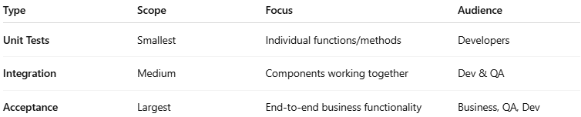

| **Type** | **Scope** | **Focus** | **Audience** |
| --- | --- | --- | --- |
| **Unit Tests** | Smallest | Individual functions/methods | Developers |
| **Integration** | Medium | Components working together | Dev & QA |
| **Acceptance** | Largest | End-to-end business functionality | Business, QA, Dev |

#### 

#### Explain

**# Source**: **Chatgpt (GPT-5-Standard) at [8/13/2025]**

You’ve got the essence of **Acceptance Test-Driven Development (ATDD)** right — let’s unpack it in more detail so it’s crystal clear.

##### What is ATDD?

**# Source**: **Chatgpt (GPT-5-Standard) at [8/13/2025]**

**Acceptance Test-Driven Development** is a collaborative software development practice where:

* **Business stakeholders** (product owners, customers)
* **Developers** (the people writing the code)
* **Testers/QA** (the people verifying correctness)

… work **together** to define **acceptance tests** *before* any development begins.

These acceptance tests are written in **business-readable language** (often Gherkin) so everyone understands exactly what needs to be built.

##### Key Idea

**# Source**: **Chatgpt (GPT-5-Standard) at [8/13/2025]**

* **In TDD** → Developers write *unit tests* before writing code.
* **In ATDD** → The whole team writes *acceptance tests* before writing code.
* The acceptance tests focus on **what** the system should do, not **how** it’s implemented.
* Passing these tests means the feature is done — it meets the **Definition of Done**.

##### How ATDD Works (Step-by-Step)

###### 1️⃣ Collaborate on Requirements

**# Source**: **Chatgpt (GPT-5-Standard) at [8/13/2025]**

* All parties meet to discuss the feature.
* They identify **acceptance criteria** — clear, testable conditions for success.
* Criteria are turned into executable acceptance tests.

**Example (Business-Level Language):**

If a customer buys a product for $100 and the tax rate is 10%,  
 the total should be $110.

###### 2️⃣ Write Acceptance Tests First

**# Source**: **Chatgpt (GPT-5-Standard) at [8/13/2025]**

* These tests are usually written in Gherkin or similar formats.
* They are **executable** through a tool like Cucumber, Behave, or SpecFlow.

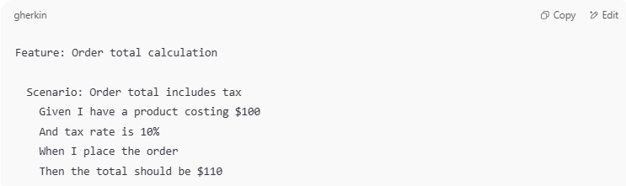

Feature: Order total calculation

Scenario: Order total includes tax

Given I have a product costing $100

And tax rate is 10%

When I place the order

Then the total should be $110

###### 3️⃣ Implement the Feature

**# Source**: **Chatgpt (GPT-5-Standard) at [8/13/2025]**

* Developers write the code that makes the acceptance tests pass.
* They may still use TDD internally for unit-level details.
* But the **driving goal** is: *"Make the acceptance tests pass."*

###### 4️⃣ Run Tests & Validate

**# Source**: **Chatgpt (GPT-5-Standard) at [8/13/2025]**

* Automated acceptance tests run against the system.
* If they pass → The feature is considered complete.
* If they fail → The code is not done yet.

###### Why ATDD is Powerful

**# Source**: **Chatgpt (GPT-5-Standard) at [8/13/2025]**

* **Shared Understanding** — Everyone agrees up front on what “done” means.
* **Reduced Miscommunication** — No surprises at the end of development.
* **Higher Quality** — Tests are based on real business needs.
* **Traceability** — Each feature’s success is measurable.

📌 **In short:** ATDD turns acceptance criteria into **living, automated tests** that guide development from day one. Passing those tests is the proof the feature is complete — no subjective “I think it’s done” debates.

#### Core Idea

**# Source**: **Chatgpt (GPT-5-Standard) at [8/13/2025]**

* Focuses on **what the system should do** from the **end-user’s perspective**.
* Acceptance tests are **written first** and act as both **requirements** and **verification**.
* Involves **all roles**: Product Owner / Business Analyst, Developers, and Testers.

#### ATDD Process

**# Source**: **Chatgpt (GPT-5-Standard) at [8/13/2025]**

1. **Collaborate** → Team discusses the feature and its acceptance criteria.
2. **Define Acceptance Tests** → Written in clear, unambiguous language (often similar to BDD “Given–When–Then” format).
3. **Automate the Tests** → Before writing feature code.
4. **Implement the Feature** → Code is developed to pass the acceptance tests.
5. **Verify** → Run the acceptance tests; feature is complete only if all pass.

#### Example (Gherkin style)

**# Source**: **Chatgpt (GPT-5-Standard) at [8/13/2025]**

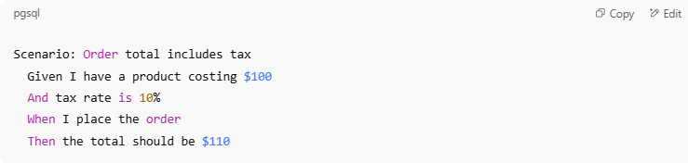

**Feature:** Order total calculation

Scenario: Order total includes tax

Given I have a product costing $100

And tax rate is 10%

When I place the order

Then the total should be $110

* This scenario becomes the **definition of done** for the feature.

##### ATDD (Acceptance Test–Driven Development) Recap

**# Source**: **Chatgpt (GPT-5-Standard) at [8/13/2025]**

* **Goal:** Collaboratively define the acceptance criteria for a feature *before* development starts.
* **Participants:** Customers/Product Owners + Developers + Testers.
* **Output:** Acceptance tests written in a clear, shared language (often Gherkin) that all parties agree on.
* **Benefit:** The acceptance test *becomes the “definition of done”* — development is complete only when the acceptance test passes.

##### Your Example in Context

###### Feature: Order total calculation

**# Source**: **Chatgpt (GPT-5-Standard) at [8/13/2025]**

* **Description:** The e-commerce system should correctly calculate the total price of an order, including tax.
* **Business Goal:** Avoid billing errors and ensure compliance with tax regulations.

###### Scenario: Order total includes tax

###### 1. Given – Setup / Preconditions

**# Source**: **Chatgpt (GPT-5-Standard) at [8/13/2025]**

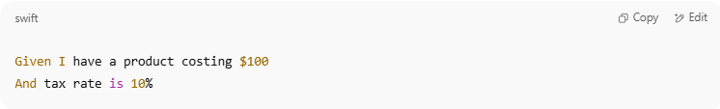

Given I have a product costing $100

And tax rate is 10%

* **Meaning:**
  + There’s a product in the system priced at $100.
  + The applicable tax rate is 10%.
  + The system’s tax rules are already configured.
* **Business Perspective:** This ensures the system has the right inputs before performing the calculation.

###### 2. When – Action

**# Source**: **Chatgpt (GPT-5-Standard) at [8/13/2025]**

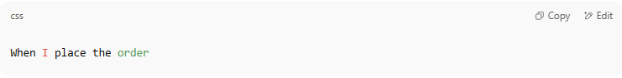

When I place the order

* **Meaning:**
  + The customer confirms and submits the order for checkout.
  + The system triggers its price calculation logic.
* **Business Perspective:** This is the moment where the system must apply tax rules correctly.

###### 3. Then – Expected Outcome

**# Source**: **Chatgpt (GPT-5-Standard) at [8/13/2025]**

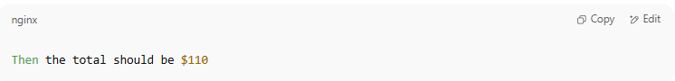

Then the total should be $110

* **Meaning:**
  + The system should add 10% of $100 ($10) to the base price, resulting in $110.
  + No rounding errors or miscalculations should occur.
* **Business Perspective:** If this passes, it shows the pricing and tax rules are applied correctly.

##### Why This Scenario Is the “Definition of Done”

**# Source**: **Chatgpt (GPT-5-Standard) at [8/13/2025]**

* In ATDD, **this test is written first** and agreed upon by all stakeholders.
* Development ends only when:  
  + This automated acceptance test runs successfully.
  + The output matches the agreed business rule.
* It’s a **living requirement** — if business rules change (e.g., tax 15%), the acceptance test is updated before coding changes happen.

##### How It Might Look in a Cucumber Test

**# Source**: **Chatgpt (GPT-5-Standard) at [8/13/2025]**

**Order_total.feature**

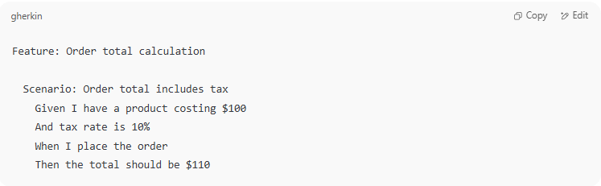

Feature: Order total calculation

Scenario: Order total includes tax

Given I have a product costing $100

And tax rate is 10%

When I place the order

Then the total should be $110

**OrderSteps.java (Step Definitions in Java + Cucumber)**

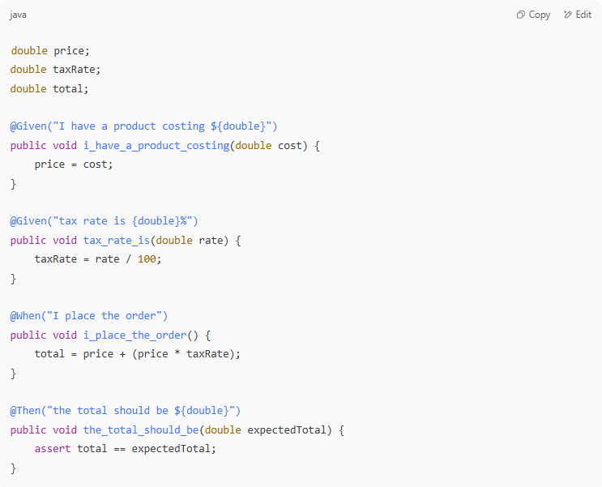

double price;

double taxRate;

double total;

@Given("I have a product costing ${double}")

public void i_have_a_product_costing(double cost) {

price = cost;

}

@Given("tax rate is {double}%")

public void tax_rate_is(double rate) {

taxRate = rate / 100;

}

@When("I place the order")

public void i_place_the_order() {

total = price + (price * taxRate);

}

@Then("the total should be ${double}")

public void the_total_should_be(double expectedTotal) {

assert total == expectedTotal;

}

When this runs and passes:

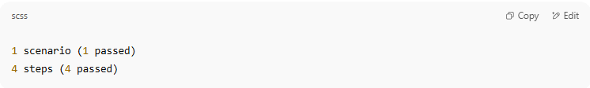

1 scenario (1 passed)

4 steps (4 passed)

✅ **Feature complete** — definition of done achieved.

#### Benefits

**# Source**: **Chatgpt (GPT-5-Standard) at [8/13/2025]**

* **Clear definition of done** agreed upon before coding.
* **Reduced misunderstandings** in requirements.
* **Better collaboration** between business and technical teams.
* **Fewer defects** since acceptance criteria are explicit and testable.
* **Living documentation** of expected system behavior.

#### ATDD vs. TDD vs. BDD

**# Source**: **Chatgpt (GPT-5-Standard) at [8/13/2025]**

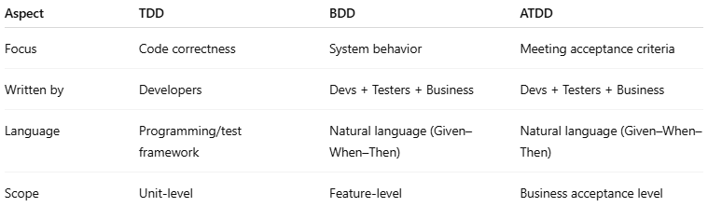

| **Aspect** | **TDD** | **BDD** | **ATDD** |
| --- | --- | --- | --- |
| Focus | Code correctness | System behavior | Meeting acceptance criteria |
| Written by | Developers | Devs + Testers + Business | Devs + Testers + Business |
| Language | Programming/test framework | Natural language (Given–When–Then) | Natural language (Given–When–Then) |
| Scope | Unit-level | Feature-level | Business acceptance level |

### 4-**Continuous Testing in CI/CD**

#### What is Continuous Testing in CI/CD

**# Source**: **Chatgpt (GPT-5-Standard) at [8/13/2025]**

**Continuous Testing in CI/CD** is the practice of running **automated tests continuously** throughout the software delivery pipeline — from code commit to deployment — so that quality issues are detected and fixed **as early as possible**.

It’s an essential part of **Continuous Integration (CI)** and **Continuous Delivery/Deployment (CD)** workflows.

#### Core Idea

**# Source**: **Chatgpt (GPT-5-Standard) at [8/13/2025]**

* Every time code changes (commit, merge, or build), a suite of automated tests runs.
* If any test fails, the pipeline stops, preventing bad code from progressing to production.
* Ensures **fast feedback** to developers.

#### How It Works in CI/CD

##### 1-Code Commit (CI)

**# Source**: **Chatgpt (GPT-5-Standard) at [8/13/2025]**

* + Developer pushes changes to the shared repository.
  + Build server (e.g., Jenkins, GitLab CI, GitHub Actions) triggers the pipeline.

**Developer Pushes Changes**

* A developer writes new code or updates existing code.
* Changes are pushed to a **shared repository** (e.g., GitHub, GitLab, Bitbucket) via **Git**.
* This triggers the **CI server** (e.g., Jenkins, GitLab CI, GitHub Actions) to start the pipeline automatically.

**Why it matters:**

* Ensures all changes are integrated frequently into a common codebase.
* Prevents “integration hell” where merging becomes messy after long delays.

##### 2-Automated Testing Stage **# Source**: **Chatgpt (GPT-5-Standard) at [8/13/2025]**

* + **Unit tests**: Verify individual functions/classes.
  + **Integration tests**: Check that modules work together.
  + **API tests**: Validate backend services.
  + **UI tests**: Simulate user interactions.
  + **Performance/security tests** (in some pipelines).

This is the **heart of CI** — every commit is tested to detect problems immediately.

**a) Unit Tests**

* **Purpose:** Verify small pieces of code in isolation — a single function, method, or class.
* **Speed:** Very fast, often run in milliseconds.

**Example:  
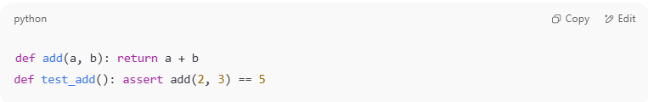** python  
def add(a, b): return a + b

def test_add(): assert add(2, 3) == 5

* **Benefit:** Catches low-level logic errors early.

**b) Integration Tests**

* **Purpose:** Ensure multiple components/modules work correctly together.
* **Example:** Verifying that the payment service correctly interacts with the order database.
* **Scope:** Broader than unit tests; may involve multiple classes, APIs, or databases.
* **Benefit:** Detects issues in how parts of the system interact.

**c) API Tests**

* **Purpose:** Test backend endpoints for correct responses, data structure, and error handling.
* **Example:** Sending a POST request to /orders and verifying HTTP 201 and correct JSON.
* **Tools:** Postman, REST Assured, pytest, Karate.
* **Benefit:** Ensures backend services behave as expected for clients.

d) UI Tests

* **Purpose:** Simulate user actions on the application interface.
* **Example:** Using Selenium to log in and check if the dashboard loads.
* **Scope:** End-to-end (E2E) testing from user perspective.
* **Benefit:** Verifies the complete user journey.

**e) Performance & Security Tests *(optional in CI, common in CD or nightly runs)***

* **Performance Testing:** Check speed, scalability, and load handling.
* **Security Testing:** Detect vulnerabilities (SQL injection, XSS, dependency scanning).
* **Benefit:** Proactive quality and security assurance.

##### 3-Feedback Loop **# Source**: **Chatgpt (GPT-5-Standard) at [8/13/2025]**

* + If all tests pass → Code moves to next stage (staging/deployment).
  + If tests fail → Developer is alerted immediately to fix the issue.

**Pass Case**

* If **all tests pass**, code moves automatically to the **next stage**:  
  + Staging environment for further checks
  + Direct deployment if using full Continuous Deployment

**Fail Case**

* If **any test fails**, the pipeline stops.
* Developer receives instant feedback (via email, Slack, or dashboard).
* They fix the issue **before merging more code**, keeping the main branch stable.

💡 *Fast feedback is key in DevOps — the earlier a bug is found, the cheaper it is to fix.*

##### 4-Deployment (CD) **# Source**: **Chatgpt (GPT-5-Standard) at [8/13/2025]**

* + Additional **smoke tests** and **regression tests** may run in staging or production environments.

Once code passes the automated testing stage:

**Staging Deployment**

* Code is deployed to a **staging environment** that mirrors production.
* **Additional tests run**:  
  + **Smoke Tests:** Quick checks that the application is up and basic functions work.
  + **Regression Tests:** Ensure old features still work after the new change.

**Production Deployment**

* With Continuous Deployment: Pushes happen automatically if staging passes.
* With Continuous Delivery: A human approves before production release.

##### 5-Post-Deployment Checks

**# Source**: **Chatgpt (GPT-5-Standard) at [8/13/2025]**

* **Monitoring:** Observes performance, error rates, and logs.
* **Synthetic Testing:** Simulated user actions running periodically to ensure uptime.
* **Rollback Mechanisms:** If a serious bug appears, system can revert to the last stable release.

Pipeline Flow Overview

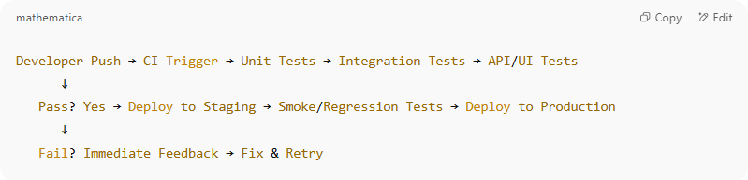

Developer Push → CI Trigger → Unit Tests → Integration Tests → API/UI Tests

↓

Pass? Yes → Deploy to Staging → Smoke/Regression Tests → Deploy to Production

↓

Fail? Immediate Feedback → Fix & Retry

#### Benefits

**# Source**: **Chatgpt (GPT-5-Standard) at [8/13/2025]**

* **Faster feedback** → Developers know within minutes if something is broken.
* **Higher quality releases** → Bugs are caught before production.
* **Reduced cost of fixing defects** → Issues found earlier are cheaper to fix.
* **Confidence in automation** → Enables safe, frequent deployments.

#### Example

**# Source**: **Chatgpt (GPT-5-Standard) at [8/13/2025]**

Imagine a **CI/CD pipeline** for a web application:

* Developer pushes a commit to main.
* Jenkins runs:  
  + **Unit tests** (JUnit)
  + **API tests** (Postman/Newman)
  + **UI tests** (Selenium/Cypress)
* Pipeline fails if any test fails → Code never reaches production until fixed.